Year 9
GCSE Geography Field Trip 2016

Name………………………………………..

The field trip is all about …………………………………………………………..

Section One

Task One: Measure the width of the river channel
at the site of the meander
How

Use a tape measure and stretch it from bank to bank. It should be kept as taut as possible to be accurate.

Get your other team members to check that it has been measured well enough.

Please note: If the river bank is sloping, keep the tape as near to the water surface as you can so that you can line it up with the bottom of the bank.

Width of river channel: ……………………….metres

Task Two: Measure the depth of the river

How

Keep the tape measure that you measured the width of the river channel in place.

You are now going to measure the depth in 3 places, so move along the river at regular intervals i.e. ¼ of the distance along, ½ of the distance along and ¾ of the distance along.

You will need to measure the depth with a metre rule.

Why

Why do you think it is important to measure the depth in 3 different places?

Write your answer below. You will use this answer in your coursework write up.

……………………………………………………………………………………………………………………………………………………………………………………………………………………………………………………………………………………………………………………………………………………………………………………………………………………………………………………………………………………………………………........

Complete the following table

Depth | cm
d1

d2

d3

Mean depth of river = ………………………………cm

To get you extra marks in your coursework, you could explain why the mean is the most appropriate average to use for this task. Write your ideas down below and you can use them later.

………………………………………………………………………………………………………………………………………………………………………………………………………………………………………………………………………………………………………………………………………………………………………………………
……………………………………………………………………………………………………………………………
……………………………………………………………………………………………………………………………
……………………………………………………………………………………………………………………………
……………………………………………………………………………………………………………………………
……………………………………………………………………………………………………………………………
……………………………………………………………………………………………………………………………

Task Three: Calculate the velocity and discharge

Choice of float

When choosing an object to act as a float, you need to think about three things. Below, complete the following statements:
- The bright colour of my float is important because......................
………………………………………………………………………………………………………………………………………………………………………………………………………………………………………………………………………………………………………………………………………………………
- The float needs to be strong enough because……………………………..

………………………………………………………………………………………………………………………………………………………………………………………………………………………………………………………………………………………………………………………………………………………
- If the float sticks out of the water too much, the wind might catch it and this is bad because then my results would be……….

……………………………………………………………………………………………………………………………………………………………………………………………………………………………………

To measure the velocity on the surface of the water, you will time how long a float takes to travel a set distance. Basically, if you know how far the float travelled, you can find its velocity.

In the write up lesson, you will be taught in more detail what velocity and discharge mean and how to calculate them.

For now:
Read the information on the following page carefully before you start!
- Measure out a length of the river area you are investigating. A distance of 10m is usually quite long enough and also keeps the maths quite easy.

- Get somebody to wade out into the river slightly upstream from your start point. This will be where the float is released and by letting the float start here, it will be able to pick up speed so that your calculations will be more reliable.

- It is important that they are able to just release it without throwing or pushing it, because it should start from rest. Why is this important? How reliable will your results be if the float was thrown in? Write your answers below (they will be used in your write up)
………………………………………………………………………………..………………………………………………………………………………..………………………………………………………………………………..………………………………………………………………………………..……………………

- A second member of your group will have to be at the downstream end so that they can catch the float

- A third member of your group will be in charge of the stopwatch and they need to be positioned at the start point
- When the float is released, the person timing, should start the stopwatch as soon as the float reaches the start point

- Stop the time when the float reaches the end point (the person at the end could shout STOP if it helps)
- Your group must repeat this procedure at least five times. Why do you think this is important? Write your thoughts
here: …………………………………………………………………………………………………………………………………………………………………………………………………………………………………..
If you have read the information carefully, you are ready to conduct the experiment. After each attempt, record the time in the table below:

Start point | Time (s)
1

2

3

4

5

Observations
Things to think about. These could be useful for your write up.
- Currents
- Obstacles

Use the space below to make any notes that could help you gain extra marks when writing up your coursework:
…………………………………………………………………………………………………………….…………………………………………………………………………………………………………….………………………………
How to calculate the velocity
You should have the time the float travelled a distance of 10 metres 5 times.
Mean time = ……………………..seconds
Remember: to mentally divide by 5, you divide by ten then
double your answer!

Once you know the mean time, you can work out the velocity by completing the following calculation:

Distance ÷ Average Time = …………………..

So, now you have calculated that the surface velocity is:

……………………. metres per second.

Section Two
Task Four
Sketch the meander and mark on the start point.

Task Five: Bed load
Collect a stone at random from the river bed at three different points across the width of the channel you are investigating.
Mark on your diagram above, the collection points and label them Pebble 1, Pebble 2 and Pebble 3.
You now need to estimate the size of your pebbles so that you can classify them. To do this, get a ruler and measure the (a) long axis, (b) middle axis and (c) short axis. Use the diagram as a guide.
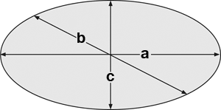
You can use Power's Index below, to classify the pebble as very angular, angular, sub-angular, sub-rounded, rounded or very rounded.
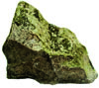 | 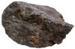 | 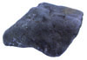 | 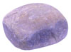 | 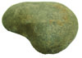 | 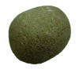
very angular | angular | sub-angular | sub-rounded | rounded | very rounded

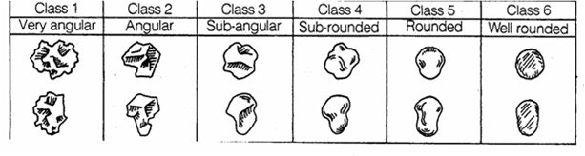

 | Size of pebble 1 | Size of pebble 2 | Size of pebble 3
Long axis

Mid axis

Short axis

Shape

Why are we looking at stones?
Classifying stones is an important part of your geography coursework. You need to know what type of river bed your stream is flowing on. Think about the following points and write any thoughts below:
- Channel roughness
- Increased friction
- Reduction in velocity
…………………………………………………………………………………………………………....…………………………………………………………………………………………………………....…………………………………………………………………………………………………………....…………………………………………………………………………………………………………....…………………………………………………………………………………………………………....…………………………………………………………………………………………………………....…………………………………………………………………………………………………………....…………………………………………………………………………………………………………....…………………………………………………………………………………………………………....…………………………………………………………………………………………………………....………………………………

This task brings you to the end of your geography field trip.
All your findings today are extremely important and will need to be written up in more detail when you get back to college.
There will be a follow up session where you will be taught more on what velocity and discharge is. Further calculations can then be completed along with support given to help you analyse your data. Your coursework can then be written up and will be worth 25% of your final GCSE grade.

The Geography and Maths Departments
hope you enjoyed your field trip!

