Manchester Markets Trip
Exchange Square
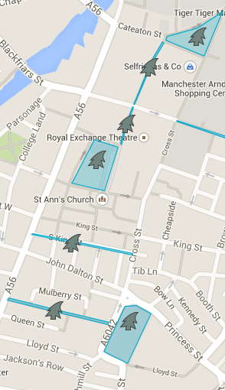
WHS is planning a trip to Manchester Markets for the whole school to take part in. Use the information provided to complete the timetable below
Albert Square
Brazennose Street
King Street
St Ann’s Square
Exchange Street
New Cathedral Street
Checkpoint | Location | Yr 7 | Yr8 | Yr9 | Yr10 | Yr11
A | Exchange Square
B | New Cathedral Street
C | Exchange Street
D | St Ann’s Square
E | King Street
F | Brazennose Street
G | Albert Square

Use the information below to complete the blank timetable

Each year group will go separately; Yr7 will set off first, followed by Yr8, then Yr9, then Yr 10 and finally Yr11
There will be a 15 minute gap between each year group starting the trip
The whole trip is expected to take all year groups 1 hour and 52 minutes
Year 7 will set off at 09 15
Checkpoint B is 10 minutes away from the start of the walk
Yr 9 are expected to arrive at Checkpoint D at 10 30
The longest section of the walk is between Checkpoint E and F, it’s expected to take 33 minutes
Year 11, the last group are expected to pass Brasennose Street Checkpoint at 11 44
Getting from Checkpoint B to C takes 6 minutes longer than walking from Checkpoint D to E
Questions
- If the start of the trip is delayed by 15 minutes what time will the year 7s complete in Albert Square?

- A year 9 pupils arrives 10.20am, between which 2 checkpoints will the year 9 group already be?

- How long would you expect it to take for pupils to walk from Exchange Street to St Ann’s Square?

- A group of 6th formers want to come to the markets as well and set off at 10.22am, what time would you expect them to finish?

- A group of year 8s stop for hot chocolate and arrive late to checkpoint D at 10.19am, what time do you expect them to finish the walk?

Complete timetable
Checkpoint | Location | Yr 7 | Yr8 | Yr9 | Yr10 | Yr11
A | Exchange Square | 09 15 | 09 30 | 09 45 | 10 00 | 10 15
B | New Cathedral Street | 09 25 | 09 40 | 09 55 | 10 10 | 10 25
C | Exchange Street | 09 42 | 09 57 | 10 12 | 10 27 | 10 42
D | St Ann’s Square | 10 00 | 10 15 | 10 30 | 10 45 | 11 00
E | King Street | 10 11 | 10 26 | 10 41 | 10 56 | 11 11
F | Brazennose Street | 10 44 | 10 59 | 11 14 | 11 29 | 11 44
G | Albert Square | 11 07 | 11 22 | 1137 | 11 52 | 12 07

