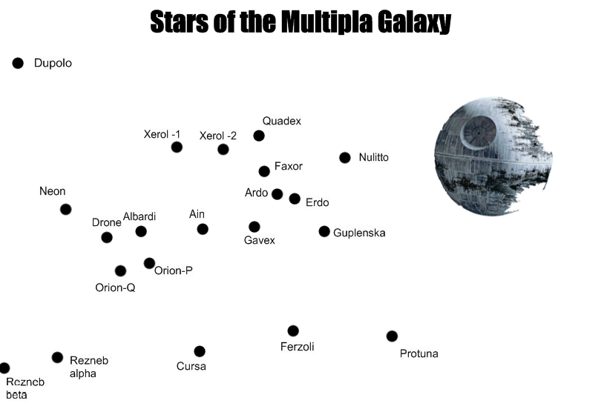
N
Team Name: School:
NB: All measurements should be taken from the centre of each star. Team Name _____________________ School: ___________________
Task 1 – Where am I? | Task 2 – Where am I?
The distance from Xerol-1 to Xerol-2 is 25758 miles.  Geographically, I am somewhere in the Multipla Galxaxy lying South of Dupolo and North of Ferzoli.  I am less than 128790 miles from Protuna  I am less than 77274 miles from Albardi.  I am at an equal distance from Nulitto and Orion -Q.  What is the nearest Star to me? | The distance from Xerol-1 to Xerol-2 is 25758 miles.  Geographically, I am somewhere in the Multipla Galxaxy lying South of Dupolo and North of Ferzoli.  I am less than 171720 miles from Dupolo.  I am less than 157410 miles from Protuna.  I am Due West of Guplenska.  I am less than 57240 miles from the Northern-most planet that is both less than 171720 miles from Dupolo and less than 157410 miles from Protuna.    Where am I?
Task 3 – Where am I?
The distance from Xerol-1 to Xerol-2 is 25758 miles.  I start a journey from Erdo. I travel on a bearing of 212º until I reach a star.  From this star, I travel 97308 miles on a bearing of 025º  From here I travel to a star on a bearing of 293º.  From here I travel due East to my nearest planet.  From here I travel precisely 81567 miles to my final location.  Where am I and what was my final bearing? | Remember to hand in your space maps clearly showing your lines of construction with your answers.  Also show any calculations you have done.  You can use a calculator for this activity.

ANSWERS

Task 1
Conversions:
25758 miles | 2 cm
12879 miles | 1 cm
128790 miles | 10 cm
77274 miles | 6 cm

Answer - GAVEX
Task 2
Conversions:
25758 miles | 2 cm
12879 miles | 1 cm
171720 miles | 13.3 cm
157410 miles | 12.2 cm
57240 miles | 4.4 cm

Answer - GAVEX
Task 3
Conversions:
25758 miles | 2 cm
12879 miles | 1 cm
97308 miles | 7.6 cm
81567 miles | 6.3 cm

Answer – DRONE 260º

