Cross Country Data Crunch
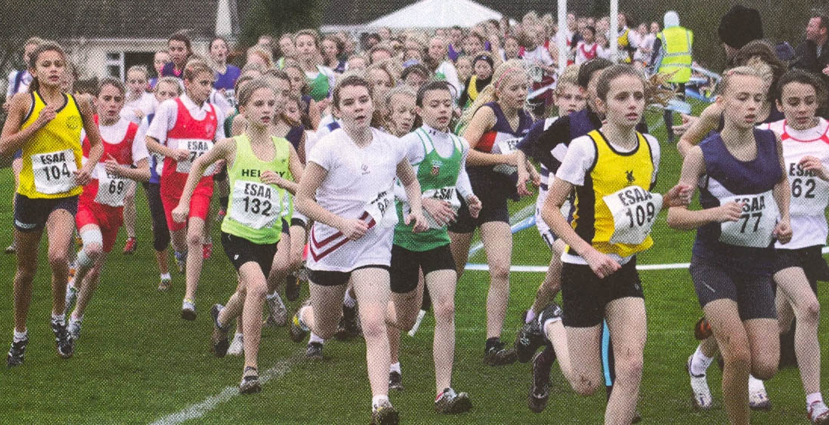
Year 9 students have just done their cross country trials in PE. All the data has been put into a spreadsheet ready for you to analyse. It’s your job to try and make sense of the data. What might you like to try and find out from the data? Think of 3 questions.
1)
2)
3)
Having all that information makes it quite hard to understand the results. So the data has very helpfully been sorted into two groups.
Group A: The girls results
Group B: The boys results
What would you expect to find if you compared the girls’ results with the boys results? Why?
___________________________________________________________
___________________________________________________________
___________________________________________________________
There are almost 180 students in Year 9 – that’s a lot of results to analyse! Any ideas what we could do to make the results simpler to look at?
___________________________________________________________
___________________________________________________________
___________________________________________________________

Sampling
Sampling allows us to pick out some results from a group. This makes analysing them a lot easier as we don’t have to think about every single result – just a few of them.
We are going to do some random sampling on the Year 9 cross country results. We are going to look at every n^{th} result in the list for both group A (the girls) and group B (the boys). What do you think n should equal?
n =
Now take a highlighter and highlight every n^{th} result in each list. For example if n = 10, you would highlight every 10th result.
Now copy the results you have highlighted below.
Girls results to be used | Boys results to be used
Now let’s compare the girls’ results with the boys’ results using our samples. A good way to compare data is to look at averages. There are three different types of averages.
- The Mode (The most common value)
- The Median (The value in the middle once the data has been put in order)
- The Mean (The value you get when you add all the data together and then share it back out between how many pieces of data you had)
It is also useful to work out the range (the highest value take away the lowest value). This shows how spread out the data is.
Work out these averages for the data in your samples.
Girls’ data

Boy’s data

How does the girls’ data compare with the boys’ data?
List at least 3 things you notice.
1)

2)

3)

Do you think these are accurate comparisons? Why?

How could you make them more accurate?

Often data makes a lot more sense when it is display in a chart or a graph. Create a dual bar chart to compare the girls’ median and mean time with the boys’ median and mean time.

