Cross Country Data Crunch
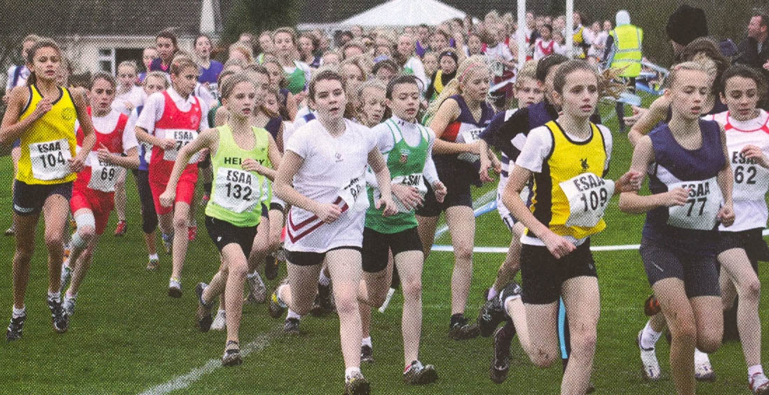
Year 9 students have just done their cross country trials in PE. All the data has been put into a spreadsheet ready for you to analyse. It’s your job to try and make sense of the data. What might you like to try and find out from the data? Think of 3 questions.
1)
2)
3)
Having all that information makes it quite hard to understand the results. So the data has very helpfully been sorted into two groups.
Group A: The girls results
Group B: The boys results
What would you expect to find if you compared the girls’ results with the boys results? Why?
___________________________________________________________
___________________________________________________________
___________________________________________________________
There are almost 180 students in Year 9 – that’s a lot of results to analyse! Any ideas what we could do to make the results simpler to look at?
___________________________________________________________
___________________________________________________________
___________________________________________________________
You are going to sort the data for the girls’ and boys’ times into groups. These groups will show the number of results between two times.
For example the group 240 ≤ t (s) < 260 would show the results greater than or equal to 240 seconds, but less than 260 seconds.
Look at the data you have. Decide what groups it would make sense to put the data into – the time intervals in each group should be the same.
Now sort the data for the girls and the boys by completing the tally charts below. (You do not need to use all the rows if you don’t want to)
Girls’ Data
Time (t) | Tally | Frequency
≤ t <

What is the modal class interval for the girls’ times? ________________
Boys’ Data
Time (t) | Tally | Frequency
≤ t <

What is the modal class interval for the boys’ times? ___________________

How do the modal class intervals for the boys’ times and the girl’s times compare? Is this what you expected?
___________________________________________________________
___________________________________________________________
___________________________________________________________

If data is put into groups it is possible to estimate the mean.
Why is it only an estimate and not an accurate result?
___________________________________________________________
___________________________________________________________
___________________________________________________________
The table below will be used to estimate the mean for the girls’ times. Can you guess what the headings of the columns might be? Once you have worked them out use them to estimate the mean.
Girls’ Data
Estimate of mean (girls’ times) = ______________ =
Now find an estimate for the mean of the boys’ times.
Boys’ Data
Estimate for mean (boys’ times) = ______________ =

How do the estimates for the boys’ and girl’s times compare?
___________________________________________________________
___________________________________________________________
___________________________________________________________
Is this what you expected? Use the next page to create a chart or graph to compare the boys’ and girls’ data.

