

Certificate of Achievement
this certificate is awarded to

___________________
for giving the Mathematical explanation of the week on the topic of ________________________.

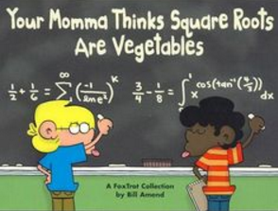

_________________________

Hyde Community College



