Polygon Panic
You have decided to deploy robots to explore the local area, trouble is your robots are going to be remote controlled and so will need a program to help them understand where to go. In order to do this you need to work out the distances the robot needs to travel between points and the angles it will need to turn through each time it changes direction.
The first path you want to program is shown on the next page
- Measure the distance in cm between each point and record it in the table
- Work out your scale factor: ______ cm : 100 m
1 cm : _____ m
- Fill this in on the table and use it to work out the real distances in metres
(Distance on map x scale factor = real distance in metres)
- Trace your map onto tracing paper. Imagine you were heading along the path from A to B. Carry on this path a bit beyond B. What angle do you have to turn through clockwise at B to be facing C? Fill this in on the table.
From | To | Distance on map (cm) | Scale Factor | Real distance  (m) | Angle to turn through (clockwise)
A | B |  | x
B | C |  | x
C | D |  | x
D | E |  | x
E | A |  | x
 |  |  |  | Total of angles
Instructions for the robot
FORWARD ________
TURN CLOCKWISE ________
FORWARD ________
TURN CLOCKWISE ________
FORWARD ________
TURN CLOCKWISE ________
FORWARD ________
TURN CLOCKWISE ________
FORWARD ________

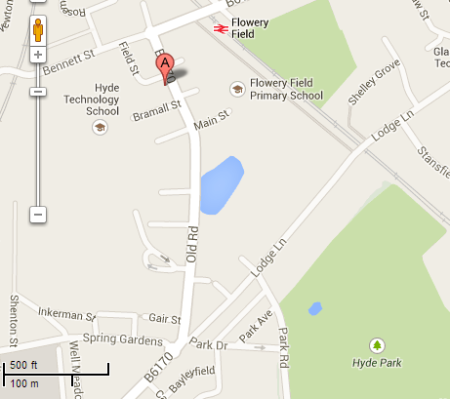
A
B
C
D
E
Finished? If you have access to computers go onto
https://maps.google.co.uk/
Get a screen shot of a map you are interested in and paste it into a Word document.
Draw a path you would like your Robot to investigate.
Work out the instructions you would need to give it.
Programming your robot using Scratch
In ICT you have used the program “Scratch” to draw out paths. Now you can check if your program works.
This table shows some programs in Scratch to draw different Polygons.
Can you work out where the angles come from? What would the program for an equilateral triangle look like.
Square | Pentagon | Hexagon
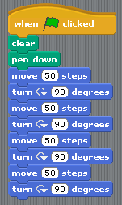 | 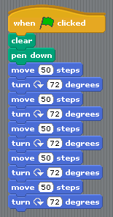 | 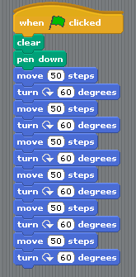
Angle turned through = ___º  Total of all angles = ____ | Angle turned through = ___º  Total of all angles = ____ | Angle turned through = ___º  Total of all angles = ____
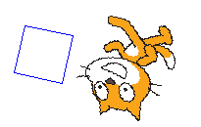 | 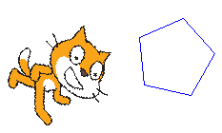 | 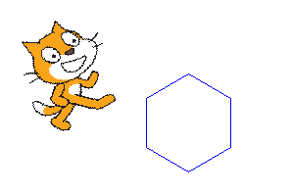

Access the Scratch program from a computer and create the program to draw the path around Hyde from the school.
Try it out.
Does your program work?
If not can you find where your errors are?
Extension
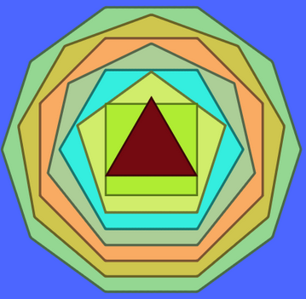
What’s the name of the shape of the path your robot mapped out?

Measure the interior angles of the shape. List them below.
(You might find it helpful to use tracing paper to get a copy of your path)

Add them together.

Complete this sentence:
I estimate that the interior angles of a ________________ sum to ________________.

For each of the shapes listed in the table below:
- Draw them on a sheet of paper
- Measure the interior angles
- Work out the total of the angles
- Fill the information in in the table.
Name of shape | Number of sides | Sum of interior angles

Can you spot a pattern?

