Activity 1: Syllables
Split these maths words into groups according to the number of syllables they have:
Hexagon | Graph | Addition | Algebra | Prime
 |  |  |  | 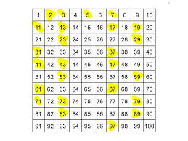
Square | Number | Angle | Polygon | Subtract
 |  |  | 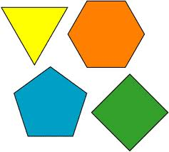
Axes | Coordinate | Acute | Obtuse | Rhombus
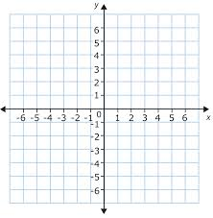 | 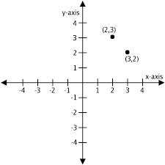 |  | 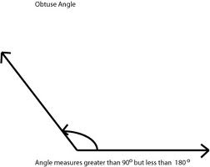
Pentagon | Triangle | Reflex | Plot | Evaluate
 |  | 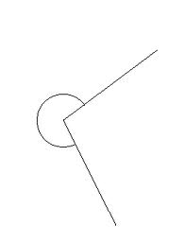

1 syllable | 2 syllables
3 syllables | 4 syllables
Can you think of any other mathematical words with these number of syllables?
Activity 2: Syllables and poetry
Work out the number of syllables in each line of this poem
Our teacher’s a football fanatic

Our teacher's a football fanatic. Syllables: ___
It's all that he has on his mind. Syllables: ___
He listens to games on his headphones, Syllables: ___
and frets when his team is behind. Syllables: ___
He jumps up and down with they're winning. Syllables: ___
He screams when they fumble a pass. Syllables: ___
We know we're supposed to be reading, Syllables: ___
but watching him's simply a gas. Syllables: ___
Our principal walked in on Friday, Syllables: ___
and he was too angry to speak. Syllables: ___
Our substitute started on Monday. Syllables: ___
Our teacher's been benched for a week. Syllables: ___
--Kenn Nesbitt
Now plot the number of syllables against the line of the poem. What do you notice?
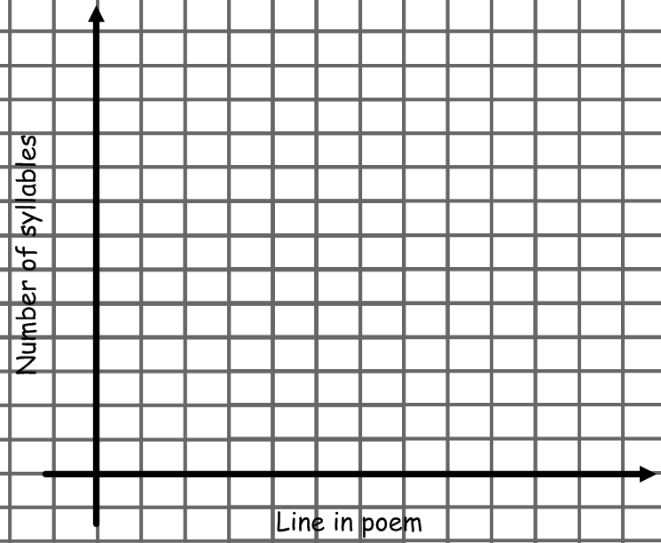
What’s the pattern? _______ lines have ____ syllables, ________ lines have ____ syllables.
Do you think syllable graphs for other poems would look the same?
Activity 3: Comparing patterns of syllables in different poems

Choose a poem from the following list
- About his person – by Simon Armitage
- At sea – by Simon Armitage
- Cataract operation – by Simon Armitage
- Education for lesiure – by Carol Ann Duffy
- Elvis’ twin sister – by Carol Ann Duffy
Simon Armitage
British Poet
Born 1963
- Hitcher – by Simon Armitage
- I am very bothered – by Simon Armitage
- It ain’t – by Simon Armitage

- Medusa – by Carol Ann Duffy
- Mother, any distance greater – by Simon Armitage
- November – by Simon Armitage
- Stealing – by Carol Ann Duffy
- Valentine – by Carol Ann Duffy
- We remember your childhood well – by Carol Ann Duffy

- Work out the number of syllables in each line
Carol Ann Duffy
Scottish Poet
Born 1955
- Plot the number of syllables against the line in the poem
- Repeat for another poem
- Compare and contrast the two poems
- Make a poster to show what you found
- Discuss your findings with other students
Extension

- Try and write a poem about a mathematical topic using the same pattern of syllables as one of the poems by Duffy or Armitage

