The Great Hyde Bake Off
There are lots of different types of scone.
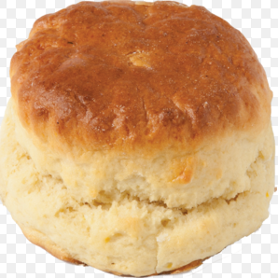 | 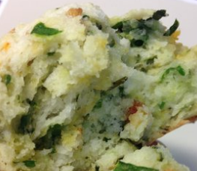 | 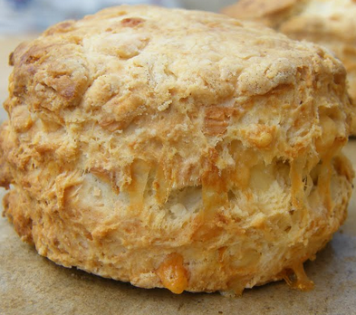 | 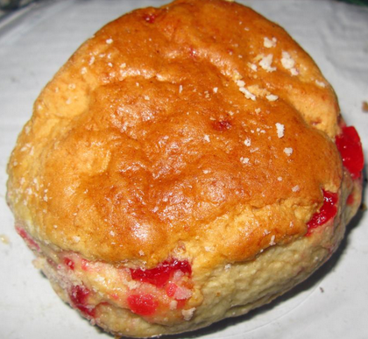 | 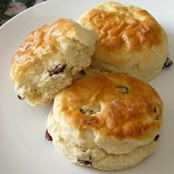
Plain scone | Garlic Scone | Cheese scone | Cherry scone | Fruit scone

Your challenge is to design and bake the best scones in Year 7.
Scones follow a fairly basic recipe.
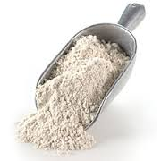
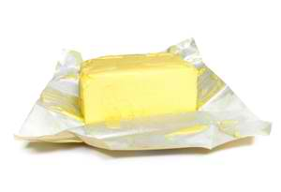
Ingredients (to make 8 sweet scones)
8 oz Self-raising flour
2 oz Butter

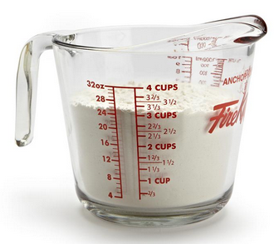
1 oz Caster sugar
5 fl oz Milk
Pinch Salt
1 Egg (Beaten to glaze)
Task 1
The measurements given above are in imperial units, the old style of measurement.
Imperial units | Metric units
1 fluid ounce | 28.4 millilitres
1 ounce | 28.3 grams
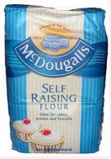
Use the information in the chart to covert these measurements to metric units.
8 ounces = _____ grams self-raising flour
A bag of flour usually weighs 1 kilogram.
What fraction of a bag of flour is this?
What’s this as a percentage of the bag?
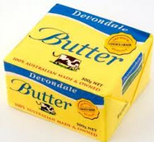
2 ounces = _____ grams butter
A pack of butter usually weighs 500 grams.
What fraction of a pack of butter is this?
What’s this as a percentage of the pack?
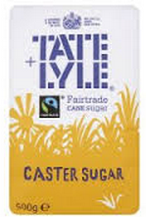
1 ounce = _____ grams caster sugar
A bag of sugar usually weighs 500 grams.
What fraction of a bag of sugar is this?
What’s this as a percentage of the bag?
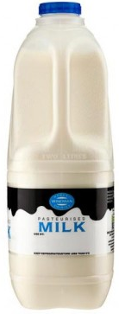
5 fluid ounces = _____ millilitres milk
A large container of milk usually holds 2 litres.
What fraction of a container of milk is this?
What’s this as a percentage of the container?
Task 2
It’s important when baking to be able to read scales accurately.
What measurements do these scales show?
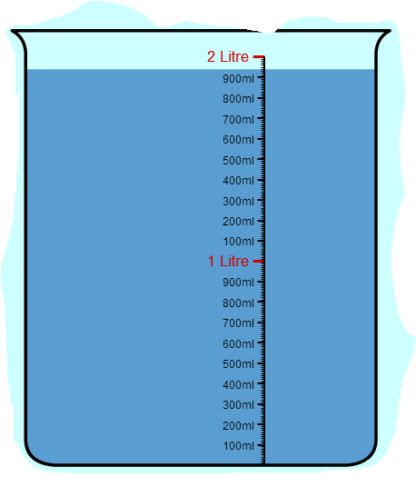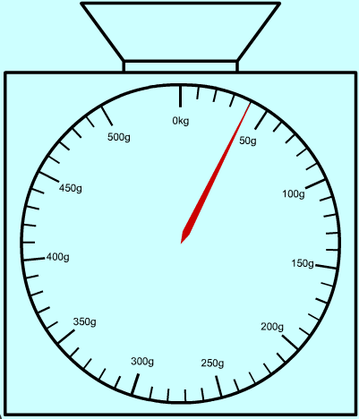
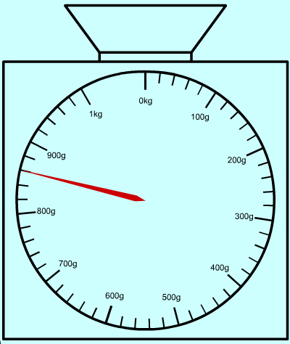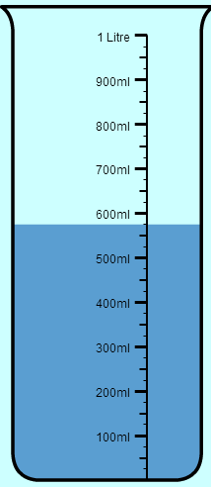

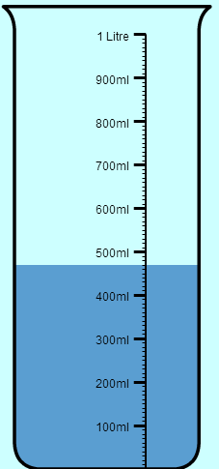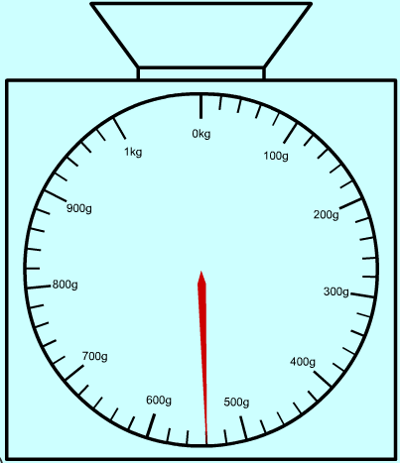

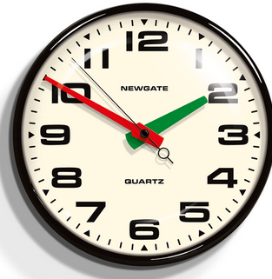
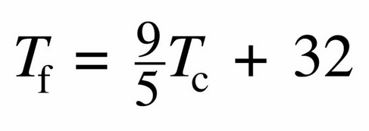
Timings
Extension
Below is the basic recipe for making your scones.
Planning your timing when you are cooking is crucial if you are going to complete dishes on time.
Convert this temperature to degrees Fahrenheit using the formula
Next to each step estimate the time it will take you to complete it.
The basic recipe
Step | Actions | Estimated time to complete
1 | Heat the oven to 220ºC/Gas Mark 7. Lightly grease a baking sheet.
2 | Measure and weigh out all your ingredients.
3 | Mix together the flour and salt and rub in the butter.
4 | Stir in the sugar and then the milk to get a soft dough.
5 | Turn on to a floured work surface and knead very lightly. Pat out to a round 2cm/¾in thick.
6 | Use a 5cm/2in cutter to stamp out rounds and place on a baking sheet. Lightly knead together the rest of the dough and stamp out more scones to use it all up.
7 | Brush the tops of the scones with the beaten egg.
8 | Bake for 12-15 minutes until well risen and golden.
9 | Remove scones from oven and leave to cool on a cooling rack.
 | Total preparation and cooking time
Where do you think you are most likely to waste time during the recipe?
How can you make sure you stay on time?
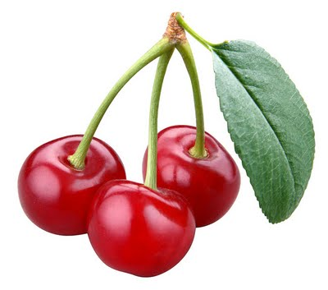
Designing your own scones
You might want to swap the sugar in your scone recipe for savoury ingredients.
Perhaps you want to add raisins or glacier cherries to give it different textures and flavours.
There might be certain spices or herbs you’d like to add.
It’s completely up to you.
In your group come up with an original design for a scone.
Work out what ingredients you will need. Use these to work out the ingredients you would need for 4 scones and then for 12 scones.
Our scone’s name: | Drawing of our scone:
Ingredients for 8 scones: | Ingredients for 4 scones: | Ingredients for 12 scones:

Extension
Price up the ingredients for 8 scones (you may use the internet for this).
What does this work out as per scone?
How much would you sell your scones for in a cake sale?
Decide on a target profit.
How many scones would you need to sell to make this profit?

